How the AK70-9 Motor Test Code Works
Oct 25, 2026 · @Nick

Read this first
This guide explains how ak70_motor_test.ino works, so the team can write and change motor code without AI. Keep the sketch open next to it: each section names the functions it covers.
Writing code like this takes three kinds of knowledge:
- How CAN moves bytes between the ESP32 and the motor (sections 2 and 3).
- Which bytes the motor expects and sends back (sections 4 to 6). All of it comes from chapter 4 of the CubeMars manual v3.2.0, which is in the project files.
- How to organize the program so it runs a steady control loop, takes typed commands and stays safe (sections 7 to 9).
Section 10 builds an 80-line version from scratch. If you can write that one yourself, you understand everything the full sketch adds on top.

1. The big picture
The sketch sits second in a chain of four parts joined by three links. A command travels down the chain as text, then bits, then a CAN frame; the motor's status frame travels back up the same way.
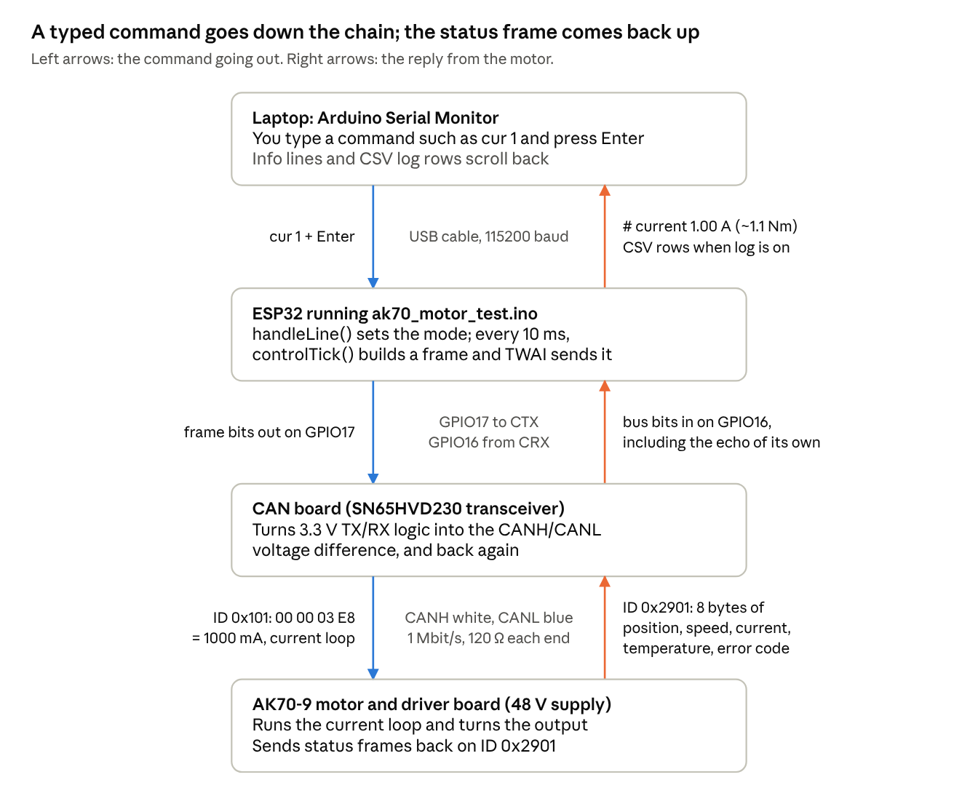
command and reply path · 4 parts, 3 links
Every wiring bug we hit was on one of the three links: wrong ESP32 pins on the middle one, swapped CANH/CANL on the bottom one. When something breaks, find which link it is before touching the code.

2. CAN basics you actually need
CAN is a two-wire bus where every device hears every message. A message is called a frame: an ID plus 0 to 8 data bytes. These are the ideas you need to write and debug motor code:
- Two wires, one difference. CANH and CANL carry a voltage difference. About 2 V apart is a dominant bit (0); nearly equal is a recessive bit (1). Swap the wires and every node reads the others backwards.
- The transceiver. The ESP32 only speaks 3.3 V logic on two pins. The SN65HVD230 board turns its TX pin into the CANH/CANL difference and turns the bus back into its RX pin. RX always echoes the bus, including the ESP32's own bits.
- Extended IDs. Standard frames have an 11-bit ID, extended frames a 29-bit ID. The AK70-9 V3 only uses extended frames, and the ID says both which motor and what kind of command.
- Bit rate. Every node must run the same speed. The motor runs 1 Mbit/s, so one bit lasts 1 microsecond.
- ACK. Every receiver that read a frame correctly pulls one bit near the end of it dominant. No ACK means nobody heard you, and the sender retries.
- Error counters. Each controller keeps a transmit error counter (TEC). Each failed send adds 8. At 128 the controller goes quiet-ish ("error passive"); past 255 it shuts itself off (bus-off) until it recovers.
- Termination. One 120 Ω resistor across CANH and CANL at each end of the cable. With power off, a meter across them should read about 60 Ω.
Two failure types look different, and telling them apart saves hours:
What you see | What it means | Usual cause
No reply, and status shows txErr ≥ 128 | Frames go out, nobody ACKs | Motor unpowered or not on the wires
CAN bus-off repeating | The ESP32 sent a bit and read back a different one | Wrong ESP32 pins, CANH/CANL swapped, or a short
Garbage text in the Serial Monitor | CAN board is on the USB serial pins | Wires on TX/RX (GPIO1/3)
No ACK alone never causes bus-off: the counter stops climbing at error passive. Bus-off always means the ESP32 cannot read its own bits back.

3. The ESP32 CAN driver (TWAI)
The ESP32 has a CAN controller built in, which Espressif calls TWAI. You reach it with #include "driver/twai.h", which ships with the ESP32 board package, so there is nothing to install.
Starting it (canBegin()) takes three settings structs and two calls:
twai_general_config_t g = TWAI_GENERAL_CONFIG_DEFAULT(
(gpio_num_t)CAN_TX_PIN, (gpio_num_t)CAN_RX_PIN, TWAI_MODE_NORMAL);
g.tx_queue_len = 10; // frames waiting to go out
g.rx_queue_len = 32; // frames waiting to be read
twai_timing_config_t t = TWAI_TIMING_CONFIG_1MBITS(); // must match the motor
twai_filter_config_t f = TWAI_FILTER_CONFIG_ACCEPT_ALL();
twai_driver_install(&g, &t, &f);
twai_start();
- General picks the pins and the mode. TWAI_MODE_NORMAL sends, receives and ACKs.
- Timing sets the bit rate.
- Filter decides which IDs the hardware keeps. Accepting everything is fine for a few motors; the code sorts frames itself.
Sending (canSend()) means filling in a twai_message_t and handing it over:
twai_message_t m = {};
m.extd = 1; // 29-bit extended ID
m.identifier = (cmd << 8) | motorId; // explained in section 4
m.data_length_code = len; // 0 to 8 data bytes
memcpy(m.data, data, len);
twai_transmit(&m, 0); // 0 = never wait
The 0 timeout matters: a control loop must never stop and wait. If the send queue is full, the frame is dropped and counted in txDrops instead.
Receiving happens at the top of every loop() pass, in drainRx():
twai_message_t m;
while (twai_receive(&m, 0) == ESP_OK) handleFrame(m);
It empties the receive queue without waiting, then hands each frame to handleFrame() (section 6).
Checking health (busTick(), every 100 ms) calls twai_get_status_info(). It returns the state (running, bus-off, recovering, stopped) and the error counters that status prints. On bus-off the code calls twai_initiate_recovery(), then twai_start() once recovery finishes. That loop printed the CAN bus-off ... Recovering and CAN restarted lines you saw.

4. The CubeMars protocol: IDs and servo commands
Every command is one extended frame whose ID is (mode << 8) | motorId. The low 8 bits say which motor (1 to 255); the bits above say what to do. Motor 1's current command is therefore ID 0x101, and motor 104's (0x68) velocity command is 0x368.
The sketch uses five of the modes (manual section 4.1 lists the rest):
Mode | Command | Data bytes | What the number means
1 | Current | 4 (int32) | milliamps: A × 1000
3 | Velocity | 4 (int32) | electrical RPM (ERPM)
5 | Set origin | 1 | 0 = until power-off, 1 = saved
6 | Position + velocity | 8 (int32, int16, int16) | degrees × 10,000; ERPM ÷ 10; ERPM/s ÷ 10
8 | MIT | 8 (packed bits) | see section 5
Bytes go most-significant first ("big-endian"). putI32() splits a 32-bit number into four bytes:
void putI32(uint8_t* b, int32_t v) {
b[0] = v >> 24; b[1] = v >> 16; b[2] = v >> 8; b[3] = v;
}
Each >> slides the byte you want down to the lowest 8 bits, and storing into a uint8_t keeps only those 8 bits.
Worked example (manual section 4.4.1, motor 0x68): 4 A is 4000 mA, which is 0x00000FA0, so the frame is ID 0x168 with data 00 00 0F A0. For −4 A the int32 −4000 is stored as FF FF F0 60 (two's complement). Our test harness checked the sketch's output against these exact bytes.
With that helper, a command is three lines (sendCurrent()):
uint8_t b[4];
putI32(b, (int32_t)lroundf(amps * 1000.0f));
canSend(CMD_CURRENT, b, 4);
Speed units need one conversion. The motor counts electrical RPM of the rotor, before the 9:1 gearbox. ERPM = output RPM × 9 (gear ratio) × 21 (pole pairs), and output RPM = deg/s ÷ 6. So vel 30 (30 deg/s) becomes 5 output RPM, which is 945 ERPM. dpsToErpm() does exactly that.
The sketch re-sends the active command every control tick (100 times a second). The newest command always wins, and when the motor is set to query-reply feedback, each command also brings a status reply back.

5. MIT mode: five numbers in 8 bytes
An MIT frame carries five targets at once: position, velocity, stiffness Kp, damping Kd and a feed-forward torque. The motor then applies roughly this torque at the output:
\tau = K_p\,(p_{target} - p) + K_d\,(v_{target} - v) + \tau_{ff}
One formula covers every behavior: Kp > 0 is position control or a spring (hold), Kd alone is velocity control or damping, and Kp = Kd = 0 is pure torque.
Step 1: turn each float into an unsigned integer. Position gets 16 bits and the other four get 12 bits each, which is exactly 64 bits. Each value's known range is stretched onto 0 to 2^bits − 1:
uint16_t floatToUint(float x, float lo, float hi, int bits) {
x = clampf(x, lo, hi); // stay inside the range
return (uint16_t)((x - lo) * (float)((1 << bits) - 1) / (hi - lo));
}
The ranges come from the AK70-9 row of the manual's table (section 4.2): position ±12.56 rad, velocity ±30 rad/s, torque ±32 N·m, Kp 0 to 500, Kd 0 to 5. If they don't match the firmware, every value lands scaled wrong. For example, position 0 rad becomes (0 + 12.56) × 65535 ÷ 25.12 = 32767 = 0x7FFF, and Kd 2 becomes 2 × 4095 ÷ 5 = 1638 = 0x666.
Step 2: pack the bits. The 12-bit values don't fit whole bytes, so neighbours share a byte:
Byte | Holds
0 | Kp, top 8 bits
1 | Kp, low 4 bits · Kd, top 4 bits
2 | Kd, low 8 bits
3, 4 | Position, all 16 bits
5 | Velocity, top 8 bits
6 | Velocity, low 4 bits · torque, top 4 bits
7 | Torque, low 8 bits
b[0] = kp_i >> 4; // drop the low 4 bits
b[1] = ((kp_i & 0xF) << 4) | (kd_i >> 8); // Kp's low nibble, then Kd's high nibble
b[2] = kd_i & 0xFF;
b[3] = p_i >> 8; b[4] = p_i & 0xFF;
b[5] = v_i >> 4;
b[6] = ((v_i & 0xF) << 4) | (t_i >> 8);
b[7] = t_i & 0xFF;
& 0xF keeps the low 4 bits, << 4 moves them to the top half of the byte, and | merges two halves. Kp 2 and Kd 2 with everything else at 0 pack to 01 06 66 7F FF 7F F7 FF.
Check MIT code by decoding your bytes back into numbers, not by matching the manual's MIT examples byte for byte. Those examples appear to use other motors' ranges, so their velocity and torque bytes don't match the AK70-9 table.

6. Reading feedback: the status frame
The motor reports its state on ID 0x2900 | motorId (function 0x29, manual section 4.3.1). It sends this either at a fixed rate or once per command, depending on the feedback setting in CubeMars Tool. All 8 bytes:
Bytes | Value | Type | Convert with
0–1 | Output position | int16 | × 0.1 → degrees
2–3 | Rotor speed | int16 | × 10 → ERPM
4–5 | Current | int16 | × 0.01 → amps
6 | Driver temperature | int8 | °C as is
7 | Error code | uint8 | 0 = no fault
handleFrame() sorts every received frame in three checks. It skips standard-ID frames, takes the low byte of the ID as the sender's motor ID, and decodes only function 0x29 from the motor it is talking to:
int16_t p = (int16_t)((m.data[0] << 8) | m.data[1]);
int16_t s = (int16_t)((m.data[2] << 8) | m.data[3]);
int16_t c = (int16_t)((m.data[4] << 8) | m.data[5]);
fb.pos_deg = p * 0.1f;
fb.vel_dps = erpmToDps(s * 10.0f); // rotor ERPM back to output deg/s
fb.cur_A = c * 0.01f;
fb.temp_C = (int8_t)m.data[6];
fb.err = m.data[7];
fb.t_ms = millis(); // when we last heard it (section 9)
The (int16_t) cast is what makes negative numbers work. Two bytes glued together form an unsigned number; the cast reads anything from 0x8000 up as negative. Without it, −0.1° would read as 6553.5°.
Torque is estimated, not measured. Output torque ≈ current × 1.0621 N·m/A (the AK70-9 torque coefficient in manual section 4.2). That's the tau_est_Nm column in the log; gearbox friction makes the real number a bit lower.
Error codes: 1 motor over-temperature, 2 over-current, 3 over-voltage, 4 under-voltage, 5 encoder fault, 6 MOSFET over-temperature, 7 motor stalled. A value of 0x77 is not a fault: it is the motor confirming a disable command.

7. Program structure
The sketch is one loop that never waits. setup() runs once to start serial and CAN; then loop() runs thousands of times a second, and each pass does four quick jobs:
- drainRx() reads every CAN frame that has arrived (section 6).
- pollSerial() reads typed characters and turns a finished line into a command (section 8).
- Every 10 ms, controlTick() runs the safety checks, sends one frame for the current mode and prints a log row.
- Every 100 ms, busTick() and hints() check the bus and print reminders.
The fixed rate. Step 3 runs at exactly 100 Hz without ever pausing:
uint32_t nowUs = micros();
if (nowUs - lastTickUs >= TICK_US) { // TICK_US = 10000 for 100 Hz
lastTickUs += TICK_US; // next tick exactly 10 ms after this one
if (nowUs - lastTickUs > 5 * TICK_US) lastTickUs = nowUs; // far behind: skip ahead
controlTick();
}
Never use delay(10) here. It freezes CAN and serial while it waits, and the real period grows by however long the rest of the loop took. The unsigned subtraction nowUs - lastTickUs keeps working when micros() wraps around to 0, about every 71 minutes.
Modes. One variable, mode, says what the motor is doing, and a switch in controlTick() sends the matching frame:
switch (mode) {
case MODE_LIMP: sendCurrent(0.0f); break;
case MODE_CURRENT: sendCurrent(curCmdA); break;
case MODE_VEL: sendVelocity(velCmdDps); break;
// ... MODE_POSVEL, MODE_MIT, MODE_SINE
}
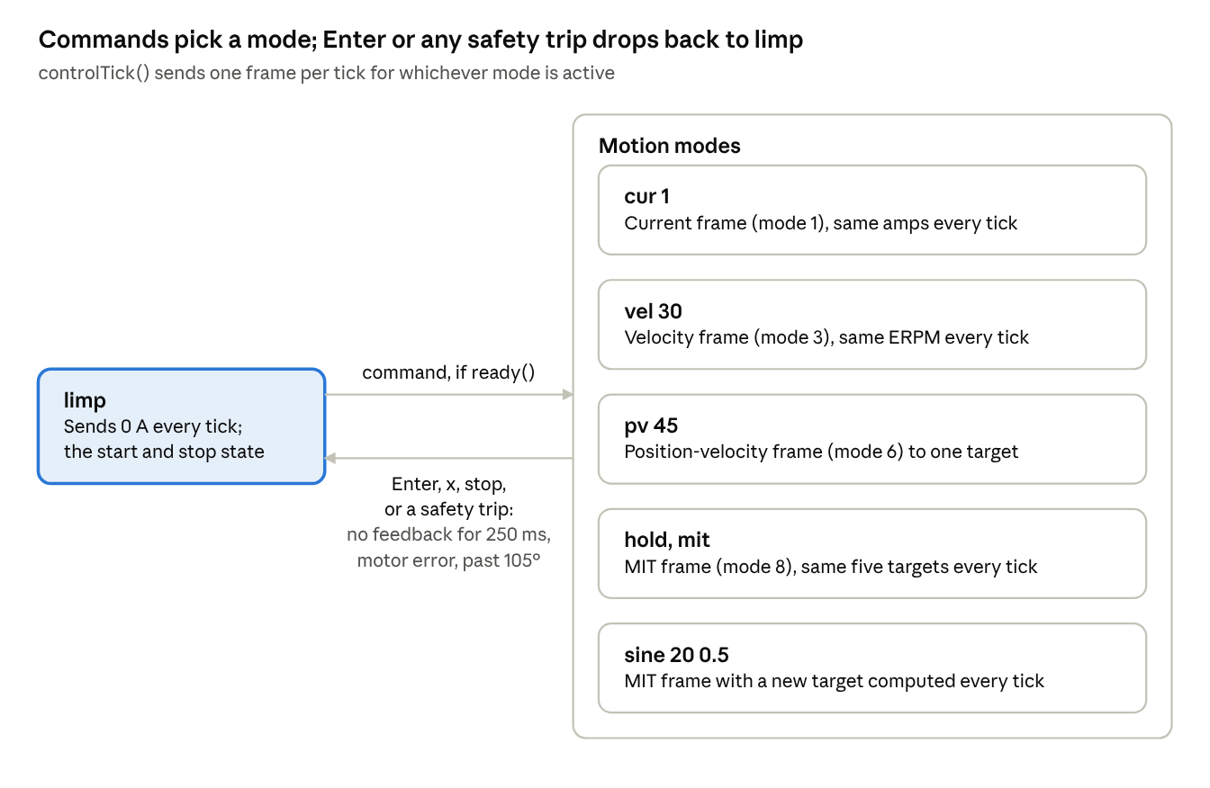
mode state machine · limp + 5 motion modes
A command can also switch straight from one motion mode to another, after the same ready() check. sine is the only mode that changes its target each tick: position = center + A·sin(2πft), and it sends the matching velocity A·2πf·cos(2πft) too, so the Kd term helps it track instead of fighting it. A ramp scales A from 0 to full over the first 2 seconds.

8. The serial command console
Commands never send CAN frames themselves. They only change mode and the target variables, and the control tick sends the frames (section 7). Keeping "what to do" apart from "when to send" is the main design idea in the sketch.
Collecting a line (pollSerial()): typed characters arrive one at a time, so they're gathered in a buffer until Enter:
void pollSerial() {
static char buf[96]; // static = survives between loop() passes
static size_t len = 0;
while (Serial.available()) {
char c = (char)Serial.read();
if (c == '\r') continue; // ignore the extra character Windows sends
if (c == '\n') { buf[len] = '\0'; handleLine(buf); len = 0; }
else if (len < sizeof(buf) - 1) buf[len++] = c;
}
}
It only reads what has already arrived, so it never pauses the loop. Avoid Serial.readStringUntil() in control code: it can wait up to a second.
Parsing it (handleLine()): sscanf pulls out the command word and up to five numbers:
char cmd[16] = "", w1[16] = "";
int nw = sscanf(s, "%15s %15s", cmd, w1); // first two words
float a[5];
int na = sscanf(s, "%*s %f %f %f %f %f", // %*s skips the command word
&a[0], &a[1], &a[2], &a[3], &a[4]); // na = how many numbers
On an empty line sscanf finds nothing (nw <= 0), which is why plain Enter stops the motor. After that, a chain of else if (!strcmp(cmd, "cur")) branches handles each command. Every motion branch follows the same four steps:
- Check the arguments are there (na).
- Check the motor is ready to move (ready(), section 9).
- Clamp the numbers to the bench limits (clampWarn()).
- Store the targets and set mode.
To add a command, copy one branch, change those four steps, and add a line to printHelp().

9. The safety layer
Safety is checked twice: once when a command is accepted (ready()), and again on every control tick while it runs. The first check stops bad commands; the second catches things that change mid-motion, like a loose wire. Each rule exists because of a specific failure:
Rule | Where in the code | What goes wrong without it
Bench limits: 5 A, 360 deg/s, 720 deg/s², 7 N·m, Kp ≤ 60, Kd ≤ 3 | LIM_* constants, clampWarn() | A typo like cur 50 asks for 50 A
No feedback for 250 ms → limp | feedbackFresh() | A wire comes loose and nobody is watching the motor
Motor error code ≠ 0 → limp | ready(), controlTick() | The code keeps driving into an over-current or over-temperature fault
Soft limits ±100° from origin (stop at 105°) | insideLimits(), targetOk() | The joint swings past its range
MIT target at most 30° from the current angle | mit command | A stiff spring aimed far away snaps to it at full torque
Sine fades in over 2 s, peak speed checked | sine command, MODE_SINE | The swing starts with a jerk
Limp means sending 0 A, not going silent | MODE_LIMP | The motor is left holding an old command
The per-tick check sits at the top of controlTick():
if (mode != MODE_LIMP) {
if (!feedbackFresh()) goLimp("feedback timeout");
else if (fb.err) goLimp("motor error");
else if (limitsArmed && fabsf(fb.pos_deg) > LIM_POS_DEG + 5.0f)
goLimp("soft position limit");
}
Software can't cover everything. If the ESP32 crashes or the bus goes down, no 0 A command can get out, so keep a hardware stop that cuts motor power: the supply's output switch on the bench, a real e-stop on the exoskeleton. The bench limits above are for a clamped motor; the team should set separate, lower limits before it's worn.

10. Build it yourself
This 80-line sketch is the whole idea with nothing extra: start CAN, send a current command 100 times a second, decode the reply, and stop if the reply goes missing. Type it in yourself rather than pasting; that's where it sticks. It was compiled and tested against stand-in driver headers, and its bytes follow the manual's format (0.5 A sends 00 00 01 F4).
// minimal_motor.ino: the smallest useful AK70-9 V3 test.
// Type a current in amps (e.g. 0.5) and press Enter. An empty line = 0 A (stop).
#include <Arduino.h>
#include "driver/twai.h"
const int TX_PIN = 17; // ESP32 -> CAN board CTX
const int RX_PIN = 16; // ESP32 <- CAN board CRX
const uint8_t MOTOR_ID = 1;
const float MAX_AMPS = 2.0f; // small on purpose for a first test
float cmdAmps = 0; // what we want
float posDeg = 0, curA = 0; // what the motor last told us
uint32_t lastFeedbackMs = 0; // when it last told us
void sendCurrent(float amps) {
int32_t mA = (int32_t)lroundf(amps * 1000.0f);
twai_message_t m = {};
m.extd = 1; // 29-bit extended ID
m.identifier = (1u << 8) | MOTOR_ID; // mode 1 = current loop
m.data_length_code = 4;
m.data[0] = mA >> 24; m.data[1] = mA >> 16; // big-endian int32
m.data[2] = mA >> 8; m.data[3] = mA;
twai_transmit(&m, 0); // 0 = never wait
}
void readFeedback() {
twai_message_t m;
while (twai_receive(&m, 0) == ESP_OK) {
if (m.extd && m.identifier == ((0x29u << 8) | MOTOR_ID) && m.data_length_code == 8) {
posDeg = (int16_t)((m.data[0] << 8) | m.data[1]) * 0.1f;
curA = (int16_t)((m.data[4] << 8) | m.data[5]) * 0.01f;
lastFeedbackMs = millis();
}
}
}
void readSerial() {
static char line[32];
static int n = 0;
while (Serial.available()) {
char c = (char)Serial.read();
if (c == '\n') {
line[n] = '\0';
n = 0;
cmdAmps = constrain(atof(line), -MAX_AMPS, MAX_AMPS);
Serial.printf("current -> %.2f A\n", cmdAmps);
} else if (c != '\r' && n < 31) {
line[n++] = c;
}
}
}
void setup() {
Serial.begin(115200);
twai_general_config_t g = TWAI_GENERAL_CONFIG_DEFAULT(
(gpio_num_t)TX_PIN, (gpio_num_t)RX_PIN, TWAI_MODE_NORMAL);
twai_timing_config_t t = TWAI_TIMING_CONFIG_1MBITS();
twai_filter_config_t f = TWAI_FILTER_CONFIG_ACCEPT_ALL();
twai_driver_install(&g, &t, &f);
twai_start();
Serial.println("Type a current in amps and press Enter. Empty line = stop.");
}
void loop() {
readFeedback();
readSerial();
static uint32_t lastTick = 0;
if (millis() - lastTick >= 10) { // 100 Hz control tick
lastTick = millis();
bool fresh = millis() - lastFeedbackMs < 250;
if (!fresh && cmdAmps != 0) { // safety: no feedback -> stop
cmdAmps = 0;
Serial.println("no feedback -> stopped");
}
sendCurrent(cmdAmps);
static int k = 0;
if (++k % 10 == 0) Serial.printf("pos %.1f deg cur %.2f A\n", posDeg, curA);
}
}
Once it runs, grow it one feature at a time and test each before the next. Each step uses one section of this guide:
- ☐ Velocity mode (section 4): copy sendCurrent(), change the mode to 3 and send ERPM. Check that 30 deg/s gives one output turn in about 12 s.
- ☐ CSV logging: print millis(), position and current on one comma-separated line every tick, paste it into a spreadsheet and plot position against time.
- ☐ MIT spring (section 5): write floatToUint() and the packing, then hold the current angle with Kp 5, Kd 0.3. Before running it, decode your bytes back by hand.
- ☐ Bus health (section 3): print tx_error_counter and state from twai_get_status_info() when you type status.
- ☐ Second motor: give it ID 2 in CubeMars Tool and wire it to the same CANH/CANL pair, with 120 Ω only at the two ends of the cable. Store feedback in arrays (posDeg[2]) and use m.identifier & 0xFF to tell which motor replied.

11. References
Keep these open while you write motor code:
- CubeMars AK Series Product Manual v3.2.0 (in the project files). Section 1.3 gives the wire colors (white = CAN_H, blue = CAN_L). Section 4.1 covers the servo commands, 4.2 MIT mode and the parameter table, 4.3.1 the status frame, and 4.4.1 the example frames to test your bytes against.
- ESP-IDF TWAI driver, v5.3: the exact API the sketch uses (twai_driver_install(), twai_transmit(), bus-off and recovery). Newer versions of that page, such as v5.5.4, describe a replacement API (twai_node_*). If a future ESP32 board package drops driver/twai.h, that's the one to port to.
- ESP32-DevKitC V4 Getting Started Guide: the header order behind the pin count (J3: GND, 23, 22, TX, RX, 21, GND, 19, 18, 5, 17, 16, 4, ...). GPIO16 and 17 exist only on WROOM boards like ours, not on WROVER boards.
- CAN Setup Guide and ak70_motor_test.ino in this project: the wiring that works and the full sketch this guide explains.

